Our last problem in this chapter is as follows : Let X = { 0...n−1 }, and each subset S ⊂ X is assigned an integer value[S].Our task is to calculate for each S:
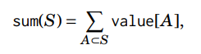i.e. the sum of values of subsets of S:
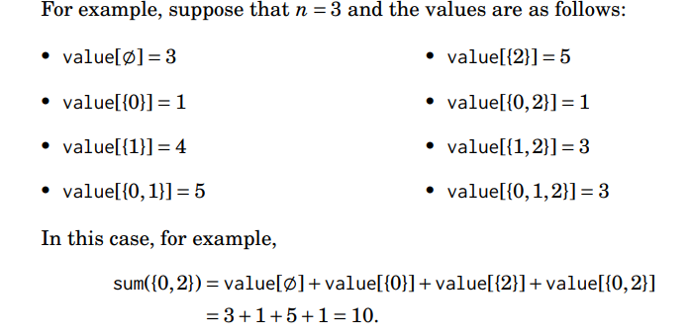
// am scrisa doar functia, fara apelul initial si citirea datelor
const int nMax = 20;
int sum, value[1 << nMax];
bool used[1 << nMax];
void Sum(int s,int lgS) {
if (used[s] == false) {
sum += value[s];
used[s] = true;
for (int p = 0; p <= lgS; ++p)
if ((s & (1 << p)) && used[s ^ (1 << p)] == false)
Sum(s ^ (1 << p), lgS - 1);
}
}

